

Electronic Signature Process
Q-0028
Revision A

Revision History
Rev | Status | Date | Author | CO # | Description
A | Draft | 1/28/05 | SLB |  | Initial Release
A | Draft | 4/29/05 | SLB |  | Removed instructions for certifying documents.

Training
Role | New | Trained in previous rev.
Document Coordinator | Read the document | Not applicable for Rev A
Document Author | Read the document | Not applicable for Rev A
Record Signer | Read the document | Not applicable for Rev A

Purpose
Electronic signatures allow personnel to approve contents of documents and records. Electronic signatures are used because MedCommons personnel are geographically dispersed and the MedCommons document and record control systems are electronic. MedCommons has chosen to use the digital signature capabilities within Adobe Acrobat Standard, which complies with 21 CFR Part 11. (See http://www.adobe.com/support/techdocs/1a546.htm for information from Adobe regarding compliance.)

Scope
This process applies to most MedCommons documents and records. These may include, but are not limited to, documents regarding MedCommons policy, processes, procedures, and records. Procedure-specific automated systems may have their own electronic signature capabilities. If so, the MedCommons document describing the procedure will describe the capabilities and how they are used.

In order to sign documents electronically using this procedure, personnel must follow or be familiar with the procedure Q-0006 (Managing Digital IDs) before beginning these steps.

Responsibilities

Document Coordinator
The Document Coordinator oversees document and record processing. The Document Coordinator ensures that only approved documents are stored in the Released documents folder. Documents requiring additional signatures shall be returned to the author in order to obtain the additional signatures required. The Document Coordinator provides assistance in creation and distribution of digital IDs and certificates and maintains archival files of certificates.

Author
In addition to creating a document draft and Change Order, it is the author’s responsibility to obtain reviewers’ approvals on the Change Order. The Author signs the document and the Change Order.

Record Signer
Personnel create a digital ID and certificate and distribute the certificate to the Document Coordinator and others who may need to validate this signature.

When personnel sign a record, such as a Change Order, they apply the digital signature per this procedure.

Records created
Digital signature certificates are created by the signers. A copy is sent to the Document Coordinator who retains it in the certificate archive.

Related Documents

- Q-0002 Document Control
- Q-0003 Control of Records
- Q-0006 Managing Digital IDs

Procedure
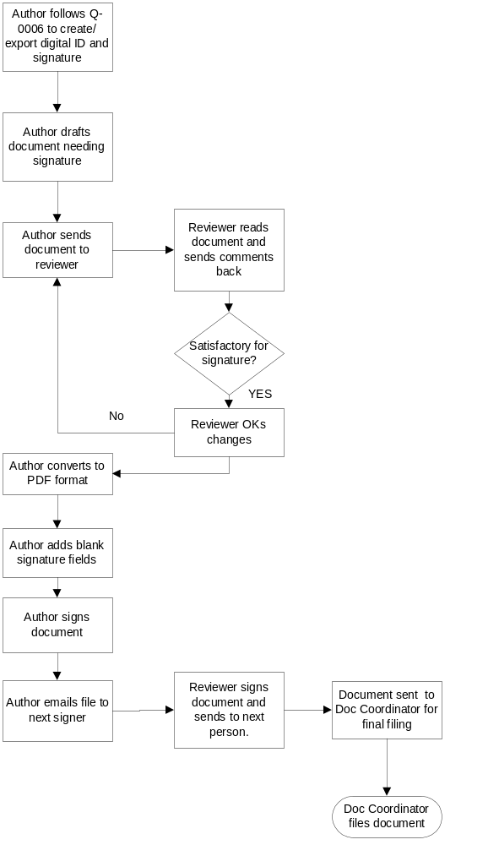

Creating a document to be signed

Note: You may be asked for a password when you sign a document, if this preference was set for this ID. Refer to document Q-0006 for instructions for setting passwords on digital IDs.

- Create the document in Word (or other application) and edit until finished. This step includes gathering input from reviewers.
- Include a space for the electronic signature field to appear under the Revision History Table on the cover page.
- Convert the document to a pdf file in Acrobat Standard. (See instructions below.)

Creating a change order (or other record) that will be signed by reviewers.

  - Create the record in Word (or other application) and edit until finished.
  - If the template does not already have one, include spaces for your and each of the reviewer’s signatures.
  - Convert the record to a pdf file in Acrobat Standard. (See instructions below.)
  - Create an electronic signature field for each reviewer.

  - Send the file to the next recipient for his signature.

Converting a document to a .pdf file

- Open the file to be converted in Acrobat.
- Select File>Create pdf from a file>browse to file.
- Click Open and wait until the conversion is completed.
- Alternately, you can use the Adobe menu extension in Word (if present) to convert the file.

Signing a record

Note: You may be asked for a password when you sign a document, if this preference was set for this ID. Refer to document Q-0006 for instructions for setting passwords on digital IDs.

- Open the pdf file you just created.
- Click the Sign button.
- Select Sign this document. Click the blank signature field where your signature will be displayed.
- Select a digital ID.
- On the Apply signature to document dialog, fill in all fields, including the reason for signing.
- Click Sign and Save. A dialog will appear saying that you have successfully signed this document.
- Email the document to next reviewer and notify the author that you have signed.

